EVENT LOCATION

POSITIVe Joint WG & MC meeting - September, 24th 2018 (Lisboa, Portugal) will take place at

Vip Executive Art’s Hotel

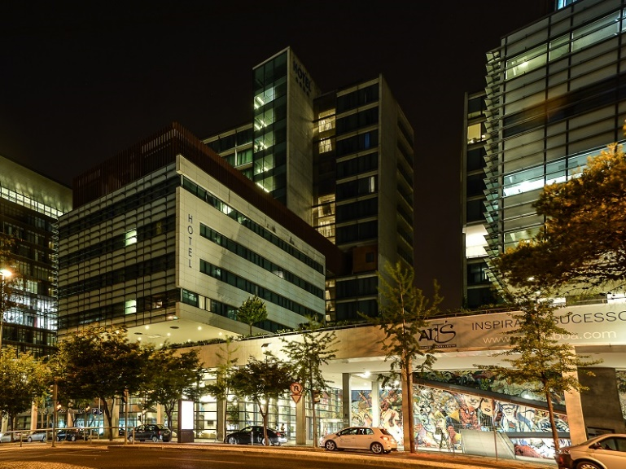

Address:
Avenida D. João II, nº 47
1998-028 Lisboa - Portugal
GPS Coordinates: 38° 46' 23.31"N | 9° 5' 52.53"W

HOW TO GET TO THE HOTEL FROM AIRPORT

Take the underground (Metro, 10 min total, each 9 min) from the Airport to Orient Station (3rd stop).

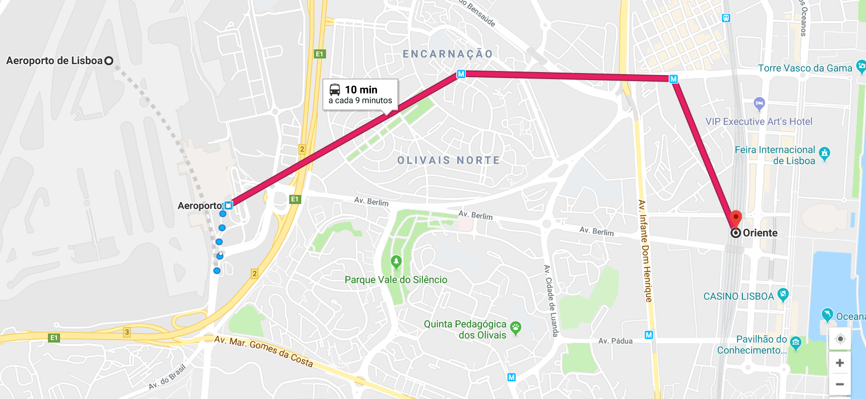

Hotel will be in a walking distance (8 minutes).
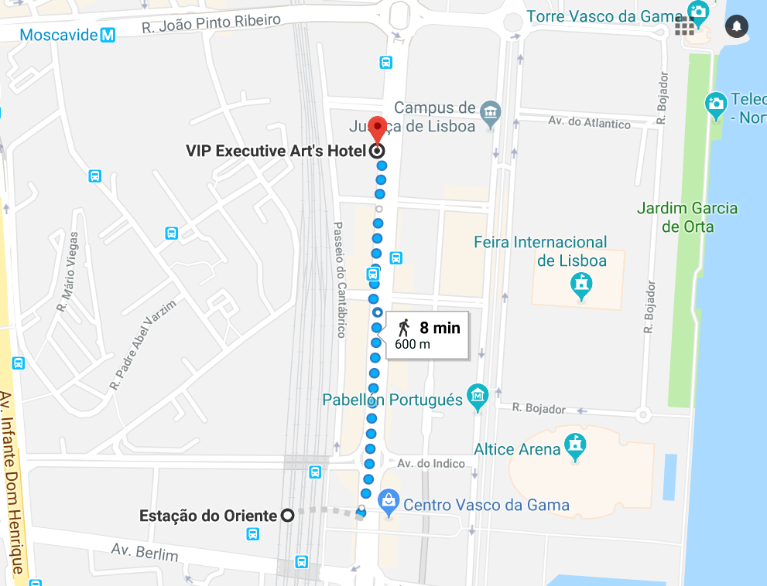

HOW TO GET TO THE POSITIVe FINAL CONFERENCE FROM THE HOTEL

Take the Undregroung (METRO) Red line at Orient Station to São Sebastião station (takes approximately 20 minutes). The conference venue is in 10 minutes walking distance (850m).

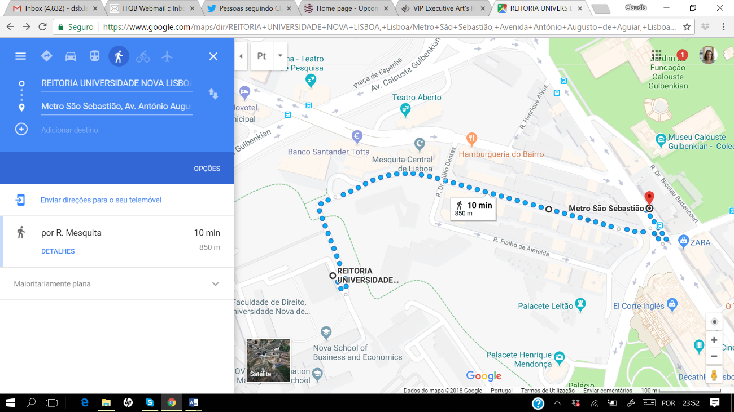
Conference Venue

